Synopsis

Network Intrusion Detection for Cyber Security using KNN

Problem Id: 09

Student Name: ASMITA (TEAM LEADER)
University Roll number: 2028676
Section: U

Student Name: NEHA NEGI
University Roll number: 2028455
Section: U

Student Name: ADITI SHARMA
University Roll number: 2028618
Section: U

- Problem Description:
In today’s digital world, network security has become very important due to the rapid increase in cyber attacks. Large organizations and systems generate huge volumes of network traffic, making it very difficult to manually identify whether the traffic is normal or malicious. Intrusion detection systems help in identifying suspicious patterns and protecting the system from attacks.
This project focuses on developing a simple Network Intrusion Detection System using Machine Learning techniques. The system will analyze network-related features such as Packet_Size, Connection_Duration, and Error_Rate to detect abnormal behavior.
The dataset will be collected from Kaggle (such as NSL-KDD). The data will be preprocessed and normalized using StandardScaler to ensure fair comparison between features. A K-Nearest Neighbors (KNN) classifier will be used to classify the network traffic as normal or malicious.
To improve model performance, the optimal value of K will be selected using the Elbow Method. Finally, the model will be evaluated using performance metrics such as accuracy, precision, recall, and F1-score to measure its effectiveness in detecting intrusions.

- Steps of Implementation:
ML pipeline used:
1. Dataset Collection
The dataset will be collected either from Kaggle (like NSL-KDD) or created manually using simulated data. This dataset contains information about network traffic which helps in identifying intrusion patterns.

2. Data Selection
From the dataset, only relevant features such as Packet_Size, Connection_Duration, and Error_Rate will be selected. This helps in reducing unnecessary complexity and improves model efficiency.

3. Data Preprocessing
The data will be cleaned by handling missing values, removing duplicates, and correcting inconsistent entries. This step ensures that the dataset is accurate and ready for analysis.

4. Feature Scaling (StandardScaler)
Since KNN is a distance-based algorithm, feature scaling is required. StandardScaler will be used to normalize the data so that all features have equal importance.

5. Train-Test Split
The dataset will be divided into training and testing sets. The model will learn from the training data and will be tested on unseen data to evaluate its performance.

6. KNN Model Training
The K-Nearest Neighbors algorithm will be applied to train the model. It classifies data points based on the nearest neighbors in the dataset.

7. Elbow Method
Different values of K will be tested and plotted on a graph. The optimal value of K will be selected where the error rate starts to decrease slowly.

8. Model Prediction
The trained model will be used to predict whether the network traffic is normal or malicious using test data.

9. Model Evaluation
The model will be evaluated using:
- Accuracy (overall correctness)
- Precision (correct positive predictions)
- Recall (ability to detect actual attacks)
- F1-score (balance between precision and recall)

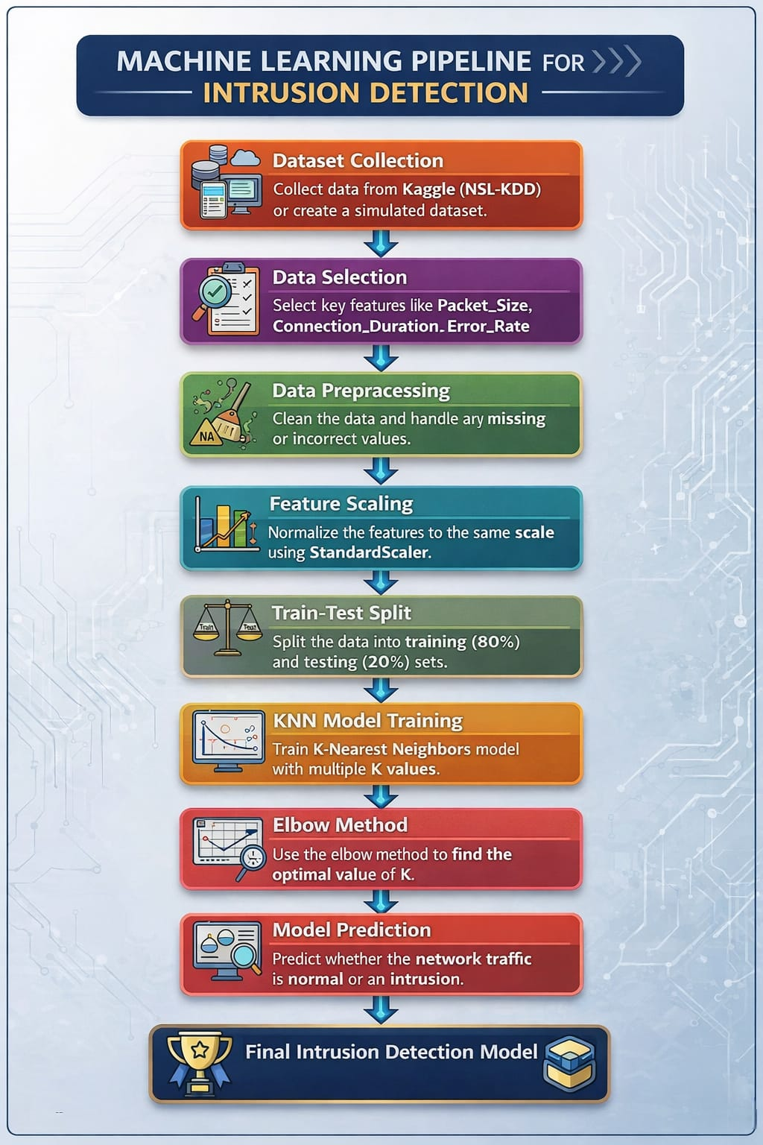
Fig.1 Architecture Diagram

- Expected Modules/ Libraries to be used :
  - NumPy
Used for numerical calculations and generating random data.
  - Pandas
Used to handle and organize the dataset.
  - Scikit-learn
Used for KNN, StandardScaler, and evaluation metrics.
  - Matplotlib / Seaborn
Used to create graphs like the Elbow plot.

- Expected Evaluation metrics and Plots to be used:
- Accuracy
Shows overall correct predictions.
- Precision
Shows how many predicted attacks were actually correct.
- Recall
Shows how many real attacks were correctly detected.
- F1-Score
It is the balance between precision and recall and gives a better overall performance measure.
- Confusion Matrix
Shows correct and incorrect predictions.
- Elbow Plot
Used to find the best value of K.

- Required topics from the subject:
- Data Preprocessing
It involves cleaning and preparing raw data so that it can be used for machine learning models.
- Machine Learning (KNN Algorithm)
KNN is a supervised learning algorithm that classifies data based on the nearest neighbors.
- Data Visualization
Visualization techniques help in understanding patterns and model performance.

Platform Required:
- Visual studio
- Jupyter notebook
- Python (IDLE)

- References:
- https://www.kaggle.com/datasets/hassan06/nslkdd
- https://en.wikipedia.org/wiki/Machine_learning
- https://scikit-learn.org
- https://www.geeksforgeeks.org

